1. Without age:

features = list(column_list - set(["age"]))

1. Without JobType:

features = list(column_list - set(["JobType", "SalStat"]))

1. Without EdType  
   features = list(column_list - set(["EdType", "SalStat"]))  
   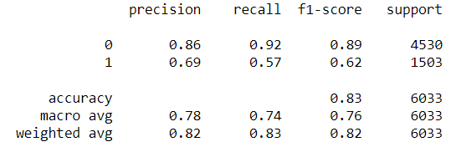
2. Without maritalstatus  
   features = list(column_list - set(["maritalstatus", "SalStat"]))  
   Table

   Description automatically generated with medium confidence
3. Without occupation  
   features = list(column_list - set(["occupation ", "SalStat"]))  
   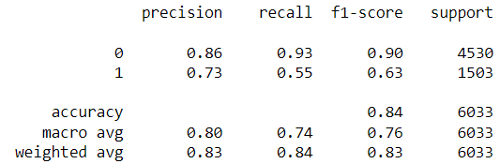
4. Without relationship  
   features = list(column_list - set(["relationship", "SalStat"]))  
   Table

   Description automatically generated with medium confidence
5. Without race  
   features = list(column_list - set(["race", "SalStat"]))  
   Table

   Description automatically generated with medium confidence
6. Without gender  
   features = list(column_list - set(["gender ", "SalStat"]))  
   Table

   Description automatically generated with medium confidence
7. Without hoursperweek  
   features = list(column_list - set(["hoursperweek", "SalStat"]))  
   Table

   Description automatically generated with low confidence
8. Without nativecountry  
   features = list(column_list - set(["hoursperweek ", "SalStat"]))  
   Table

   Description automatically generated